Houdini Tech on the Internet (HTI):

Friends see one thing – foes another

Abstract: In this proposal we present results of research that clearly shows that the Internet is being used, with what we call HTI, to present one type of information to one audience defined as friends, and another type (confused, partial, misleading, misdirected) to another audience, called foes. We show examples employed by one foreign company to deceive specific non-national audiences (especially USA) and we go on to expose the methods and the ways being used. The methods presented here can be used by any organization, such as a terrorist group and alike. We conclude with a proposed countermeasure in the form of a software system.

Introduction:

We have come across intentional measures that manage different views for different communities of viewers. The measures themselves are neutral; they can be used for good or for bad purposes. For example, adjusting what is seen to viewers from different cultures is a good purpose; however these schemes, termed here HTI (Houdini Tech for Internet), as we found out, are also used for bad/criminal purposes, and in an organized and systematic way. Examples include, hiding messages, keeping information (such as evidence or messages) from appearing in one jurisdiction, but appearing in another (such as patent usage hiding, where you sell in friendly home market, while hiding in the foe market, e.g., where the patent comes from). Organizations use HTI methods to manage the flow of information in such a way that they thwart detection of fraud and, potentially, command and control messages.

In this proposal we show some of the methods by which internet pages can be made covert to one audience and overt to another audience. We start our proposal with a brief survey of five types of the HTI measures that are used, and then conclude with a proposed countermeasures system.

Survey of Measures:

Here we present the methods themselves, which comprise the HTI. We only present methods that we found and deduced from actual field examples. It is not a comprehensive list yet, and may never be.

- Color concealment (background and text in the same color): When the foe views the web page (after having submitted it to a translation engine) both the text and its background are the same color, thus making text invisible. One way that the designer can effect this is to install special instructions (probably in the style sheet) to foul the translation mechanism, so as to change the color of parts of the text (e.g., white text on white background).

Immediately below is an actual example taken from the internet (as of this writing, it is at: http://glovia.fujitsu.com/jp/event/kansai/02sf1113.html). The “Japanese View” easily visible text in the middle of the frame. The translated “English View” has that text translated, but it is presented in the identical color (white) as the background, hence is invisible. If you highlight the “white text” area, you would be able to see the text we have presented in the “Exposed View”.

Japanese “friend” View | English “foe” View | Exposed View
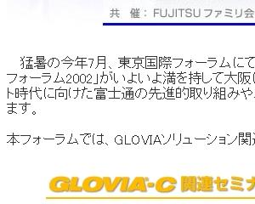 | 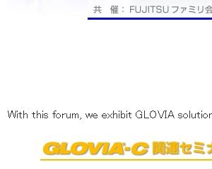 | 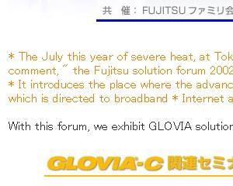

In this case, the perpetrator testified that no promotion of a subject had occurred, yet, on the internet, in Japanese, they had clearly written, “The July this year of severe heat, at Tokyo international forum it received favorable comment…” in direct contradiction to their testimony. However, English readers could not see this statement since the text’s background was the same color as the text.

There are a three courses to thwart this ploy: a) Read the page in Japanese, b) Have the translation engine “anonymously” fetch the page, and c) search for “font … color=same” where same is a color the same as the background, in this case white.

- Using image files to hide text: This is a way to put textual content in view without search engines being able to see the content. Therefore a foe cannot find the file, and a translation engine cannot translate the file (The search engine can translate encoded text and not pictures).

If you examine the figure below, you can make out five occurances of the word “EXCEL”. By putting these occurances into a graphics figure the perpetrator prevents their detection by all Search Engines. In fact, five detected occurances will, generally, cause the Search Engine to score the page much higher thusly increasing the liklihood of the page being accessed. Therefore, this is a simple and effective method for operating in a low profile.
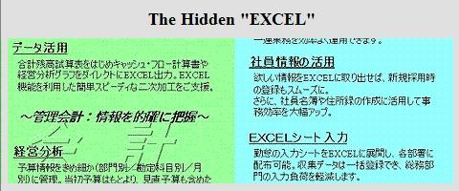

Using this device in a friendly domain, you could be given information or instructions detrimental to foes. The information could be the “keys” to a web location or the instructions to perform an operation. This is a simple, well known, and well understood device, which is, nonetheless, very general purpose and effective for going undetected (by eluding search engines and by defying translation engines).

There is no known effective way to harvest all these occurrences, character recognition programs will work in the simple instances (such as the upper right panel above), but not where there is a distracting background (such as the lower left panel above). There is a trick, though, and that is to search on the content of the URL as some will foolishly put clues to the hidden information there, such as “excel_seminar.htm”.

- Hiding text in cursors: This device puts messages into the cursor tag, a place where three views seldom visit: a) translation engines, b) casual or scanning viewer, and c) those who don’t actually place their cursor over the text. One can also see how this device used with the text hiding (#1, above) can effectively thwart the unintended viewer, that is, the “foe”.

Below, you can see that there is a long message in the original “friend view” which does not make it through translation, hence it is effectively erased by the translation engine. By going into the actual original HTML code, we extracted the Japanese message and then had just that message translated. That’s how we were able to expose the contents of the hidden cursor text.

Japanese “friend” View | English “foe” View | Exposed View
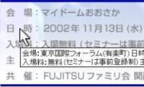 | 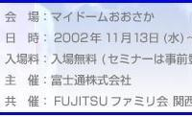 | 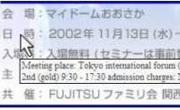
To thwart this device, it is necessary to view the page in the original language, upgrade translation engines to translate cursor tags (which are only about two years old), or examine the HTML code for the cursor tags and extract them for separate examination.

- Blocked or Dead Links: This device is simple and crude, but effective. What is done is to give the appearance of having a link, but when you click on it, nothing happens. This is most often an innocent file management error, but, as shown below, can seem quite intentional. Usually, we can’t show dead links (simply, there’s nothing to show, it’s just that the link doesn’t work).

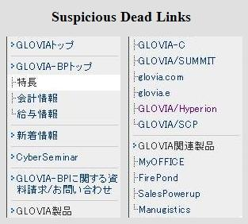 | In this instance, there over 8,000 pages devoted to “GLOVIA” and here there are links for eight GLOVIA pages (GLOVIA-BP, GLOVIA-C, GLOVIA/SUMMIT, glovia.com, ...), but, when it comes to GLOVIA-Product and GLOVIA-Related product[s], they are uniquely DEAD.  The “discovery” we wanted was to show that the technology of their product infringed on our technology, so we believe the product description was hidden to thwart us.  Note: if the background were not left white, we would never have noticed this dead link!

Thwarting and detecting this device automatically is easy in one instance and impossible (or seemingly so) in another. In the case where the link is there but it doesn’t work (usually because the target URL is not at its specified location), web crawlers regularly report these as “errors”. In the instance shown above, where the link is “suspiciously” absent, there is no known automated method available.

- Miscellaneous Devices:

  - Using aliases, misspellings, and/or abbreviations in order to prevent search engines from finding the real meaning and reference. Instead of "disclosure" we found our adversary using "disc rose" and . This confuses the translation machine, but doe not confuse the person who reads it phonetically (e.g. interchanging "r" and "l" phonetically is prevalent in Japan).
  - Outputting different pages to different viewers (perhaps based on the URL of the calling page) is a device we have experienced. In this instance, a Japanese page existed in Japan, but was unavailable in USA.
  - Interchanging fonts and languages to confound translation engines and search engines. For example, by interchanging different but legible fonts (UTF, Shift JIS, and EUC), translation machines become confused and output either strange characters or bands of question marks where legible text in the original language existed.

Countermeasures Proposal

We propose a suite of capabilities, most of which exist off-the-shelf, plus some customizing, and some logistical devices to thwart the deception and communication measures described above. The core software is available off the shelf today and is a (unicoded) web crawler. This web crawler would have to be modified to present a “browser view” upon fetching a file. This “browser view” would be “triaged” (discard, put on back-burner, or examine) by the user. If discarded or put on the back-burner, the crawler would go onto the next file, next folder, or back up, according to the user’s command.

If commanded to examine, the crawler would issue a preliminary report:
- Instances of suspicious text code (color matches background, character set switched, …)
- Instances of suspicious style code (search trap, changing style preferences, …)
- Instances of suspicious cursor code (lengthy messages, different languages, …)
- Table of foreign language (e.g., English on a Japanese page) expressions, image file names, table of bad links, and a table of style links.

Next, the page would be run through at least two translation engine approaches. One would use the original page’s URL to direct the translation engine to translate and another would use the local URL of a copy made of the original page as the reference for the translation engine. The two translation engine results would be compared and differences would be reported as suspicious.

Next the translated file would be sent to a spell checker to find misspellings and the proposed words would be appended to the translated file.

Then, an OCR program in the original language would be used to scan the images and append their output to the local copy of the original file. To this would be added a collection of typically untranslated HTML code (such as the cursor code, alt and title fields, HTML comments and meta fields usually found in HTML headers). Now, this augmented file would be sent back to the translation engine to see what was hidden.

Also, a dummy call to the original page would be compared to a search engine call (the search engine call always has the key “search” in its command to see if there is alteration dependent on whether the URL request came from a search engine or not. The same countermeasure would be used for the country code of the requesting server, however that will require remote operation of a server in various countries. This last point can be shown as fruitful, but is NOT included as a deliverable in this proposal.

The translation outputs, image files, augmented items, and the preliminary items would be used to determine if the file warranted further scrutiny. Further scrutiny might be to run a series of tests on the style sheets, for example.

The time frame for getting 50% of this up and running is probably about 4 months after a detailed specification (which should take about a month). This 4 month Beta suite would be immediately useful, but would require 2 months of refinement. In parallel, the tougher items (such as the integration of the OCR and certain “suspicious code” detectors) could take another 6 months.

The cost of the 4 month Beta, exclusive of licensing costs, may be on the order of $50,000. The remaining 6 months could well cost another $100,000 as it entails serious programming effort.

